## https://xd.adobe.com/view/2d56c888-18fb-42e4-bde7-7b58132295f8-7805/horizontal line

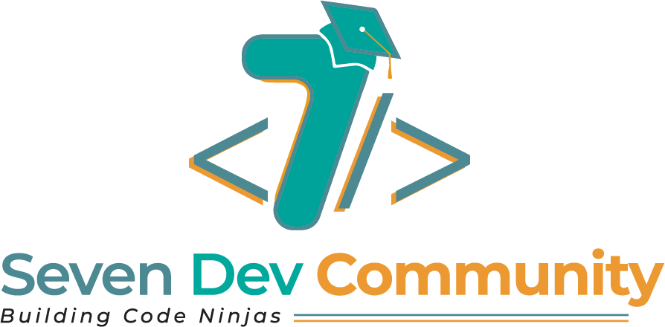

Project: Seven Dev Community Website

**─**

# Objectives of the Seven Dev Community

## Vision:

*We think, we code, we change the world!* With our brilliant ideas, we critically think on the challenges and bring forth long lasting solutions, we link various developers so as to encourage learning, resource sharing and growth and we seek to drastically change and improve on our nation, Africa and the world at large.

## Mission:

The goal of Seven Dev Community is to bring together young minds that will collectively ponder on the challenges faced by their community which could be (Social, Educational, Agricultural or Economical) and provide reliable and long lasting solutions using Technology to help increase productivity in all the sectors of their community.

# Objectives of the Seven Dev Community Website

## Showcasing what member’s can do:

This website is aimed at showing what members can do and create with the necessary skills they have acquired. This is done by projecting the various projects members are working on and the stacks they are using to implement these projects.

## Connecting Members with Mentors:

This website is aimed at bringing together members who are active and passionate about tech together with mentors [people who have been in the field of tech and are much more experienced]. These mentors will help mentor them through the processes of their various projects and passion in the world of technology.

# Requirements

1. Authentication API
2. Seamless user interface for visitors, members and mentors.
3. Database for storing and tracking Information and projects.
4. Server environment for deployment.
5. Dashboards for Members, Mentors and Admin

# Use Case Diagram

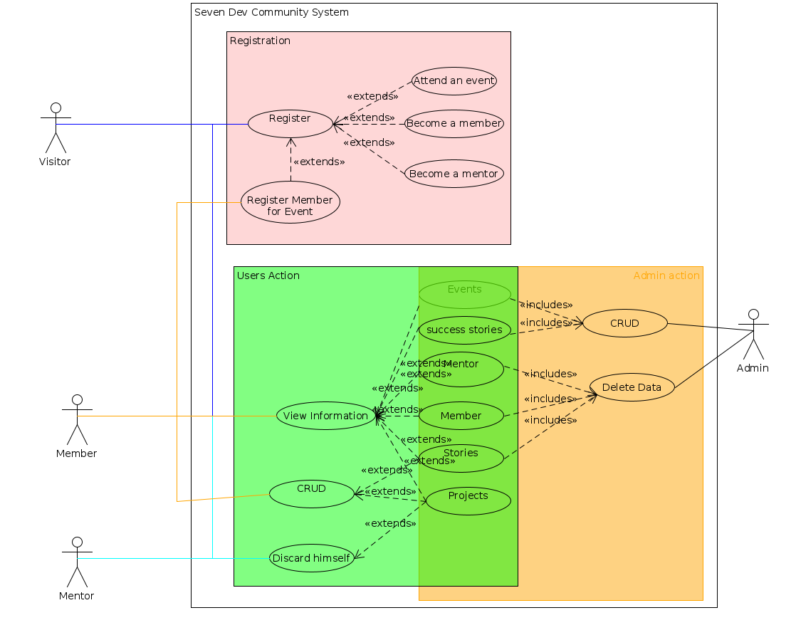

First_release Use Case Diagram

This use case diagram is used simply to show how different Users get to interact with the system.

1. **A visitor:** Someone who gets to use the website who is not a member of the Dev Community. He/She can do the following:

* View the website and sign up to attend events.
* Possibility of joining the community by either signing up as a member or mentor.
* However, the person cannot create, update or delete any information without registering.

1. **A member:** This is an authenticated user who can do the following:

* View the website and sign up for events.
* Showcase his/her projects.
* Can get a mentor or request for one.
* He has limited rights to editing just his profile, stories and projects.

1. **A Mentor:** This is an authenticated user who has the ability to do the following:

* View the website and sign up for events.
* Able to connect and mentor members on desired projects [those projects he/she is interested in working with members on].

1. **An Admin:** This is an authenticated user who can do the following:

* View website.
* He/she can create and delete events
* Delete members and mentors based on certain rules and regulations.
* Edit and delete stories based on certain rules and regulations and or standards.

# DataBase Design

## 

First release of the DataBase

This is a diagram that shows the various data that will be collected and stored in a database. It also shows how components will communicate within the document so as authomate certain processes on the website.

# Milestones

* Develop system specification.
* Develop system design.
* Implement the front-end design of the system.
* Implement the system backend for processing client requests.
* Develop tests for the core modules.
* Deploy system in test environment.
* Deploy the system in a live environment.

# Tools

* **Angular for front-end (UI/UX)**: Angular Material will be used for creating the UI.
* **Nodejs ( Backend) with TypeScript**:
* **MongoDB:** A noSQL database that will be used to store data from site and from various users.
* **Editor.js:** A JavaScript library that will enable users to CRUD their stories.
* **Auth0:** Authentication API that will be used to manage users on the site and secure their Identities.
* **Github API:** This will be used to get data of projects from members such as project description, commits, Pull request.
* **Bitbucket & git:** These tools will be used for Version Control. Two repositories will be required for this project. One for the front end application and the other for the backend. Both will have dev branches where other sub branches which will contain implementation for the different modules will be merged.
* **Visual Studio Code:** IDE to use for development.

# Team

* Kambang Sinclaire - Team lead/Developer,
* Bansi Rene - Developer
* Mambo Joy - Developer
* Dzekewong Karlson - Developer